LINK UTILI
ITALIANO
https://www.youtube.com/watch?v=jUbY_bfRkK0&feature=youtu.be
https://www.youtube.com/watch?v=3Q3w7K6bb0A&feature=youtu.be
https://www.youtube.com/watch?v=A-lBz0wFo2Y&feature=youtu.be
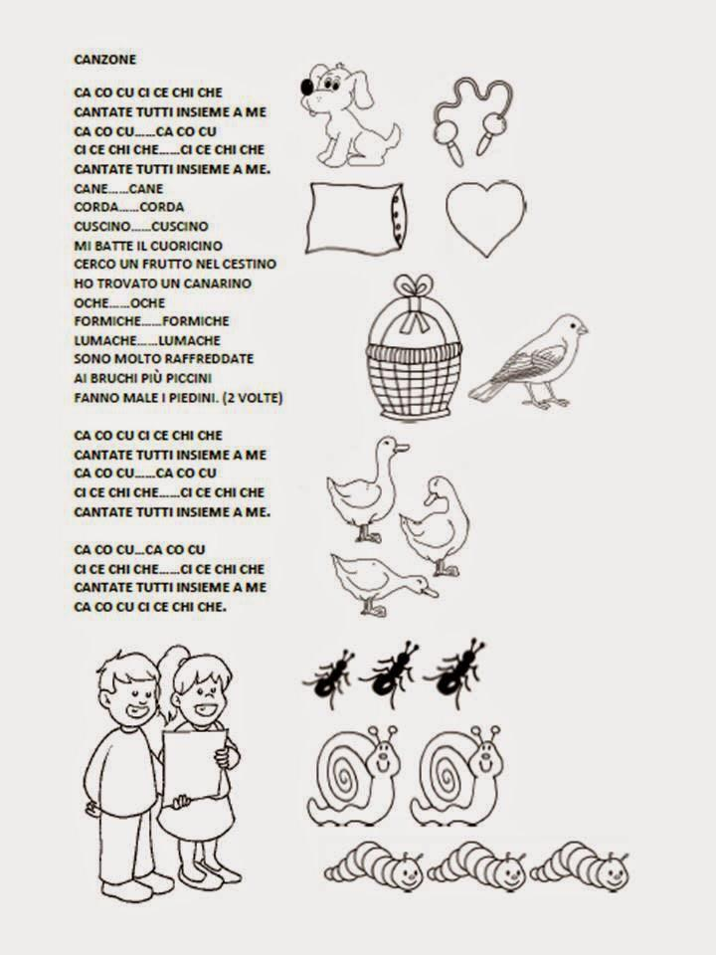
https://www.youtube.com/watch?v=lAlOAOYk-YE&feature=youtu.be
MATEMATICA:
https://www.starfall.com/h/addsub/add-machine-1/?t=288676811
https://wordwall.net/it/resource/375586/matematica/addizioni-entro-il-10
https://www.maestraanita.it/gioco-addizioni-e-sottrazioni-entro-il-10/
PRECEDENTE E SUCCESSIVO ( DA SCARICARE IL PROGRAMMA)
https://www.maestramarta.it/download/precedente-successivo/

INGLESE
https://www.youtube.com/watch?v=h9Pcd-7y3x8&feature=youtu.be
https://www.youtube.com/watch?v=_tr896y6clM&feature=youtu.be
https://www.youtube.com/watch?v=CS0phBro99Y&feature=youtu.be
https://www.youtube.com/watch?v=pHmsE1mnhgg&feature=youtu.be
https://www.youtube.com/watch?v=rgJFII2ZU9w&feature=youtu.be
https://www.youtube.com/watch?v=hjFaqDNUVFo&feature=youtu.be
